R.D.R PROJECT

3ºAno – 1º Semestre

Aulas Teórico-Práticas

laboritory

Docente:

Paulo Torres

Edição revista:

Paulo Torres

**Summary**

1 Introduction 4

2 How to work the website 5

2.1 How to connect to the website 5

2.2 How to edit an object 6

2.3 How to remove an object 6

2.4 How to add an object 7

2.5 How to confirm client request 8

2.6 How to edit columns 9

2.7 How to associate RFID card to car parts 9



# Introduction

RDR website allow user to see and manage stock of car parts stored in database. You can connect with specified user and with specific rights. The rights are admin and default.

* + Admin
    - See an object in database and website
    - Add an object in database and website
    - Edit an object in database and website
    - Toggle table columns of car parts
    - Associate RFID card to specific car parts
    - Confirm operation of default user rights
  + Default
    - See an object in database and website
    - Send a request to admin to edit or add a car part

This is the interface of main page:

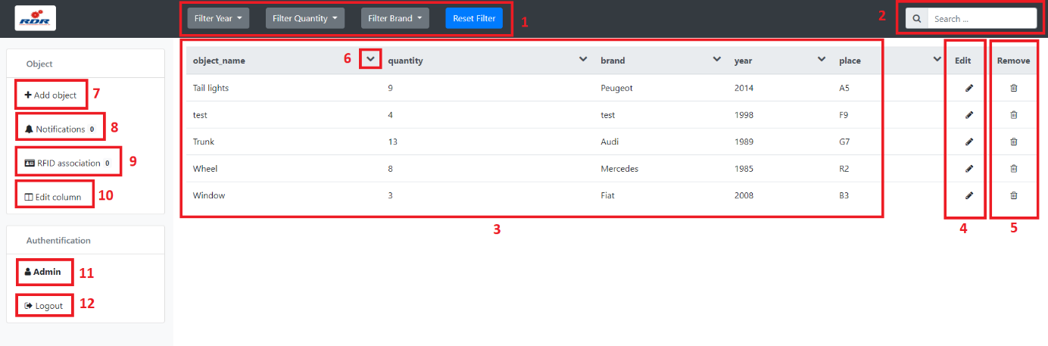

Fig 1: RDR main page

1. Filtering system for car parts
2. Searching system for car parts
3. Table view with details of each object in database
4. Shortcut to edit car parts
5. Shortcut to remove car parts
6. Sorting ascending and descending the car parts
7. Add object popup
8. Notifications popup
9. RFID association page
10. Edit column popup
11. User logged
12. Disconnect from current user

# How to work the website

## How to connect to the website

If you are disconnecting to the website, when you try to go on welcome page of RDR website, you will be redirect on login page:

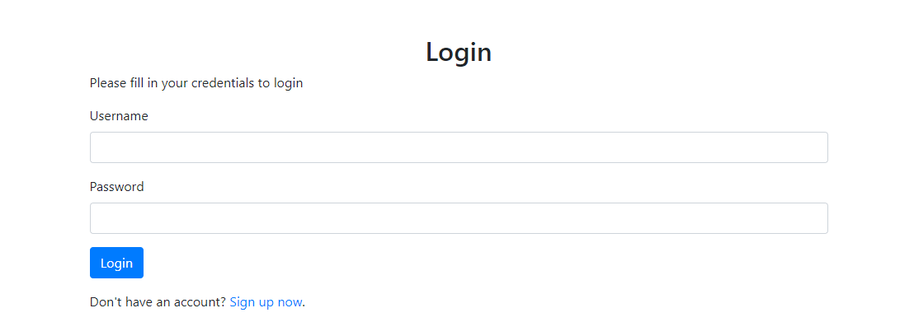

Fig 2: Login page

You need to fill the login information, by default it’s:

* + Admin user:
    - Username: admin
    - Password: admin
  + Client user:
    - Username: client
    - Password: admin

If you are connected and you want to disconnect, click on Logout button in side menu:

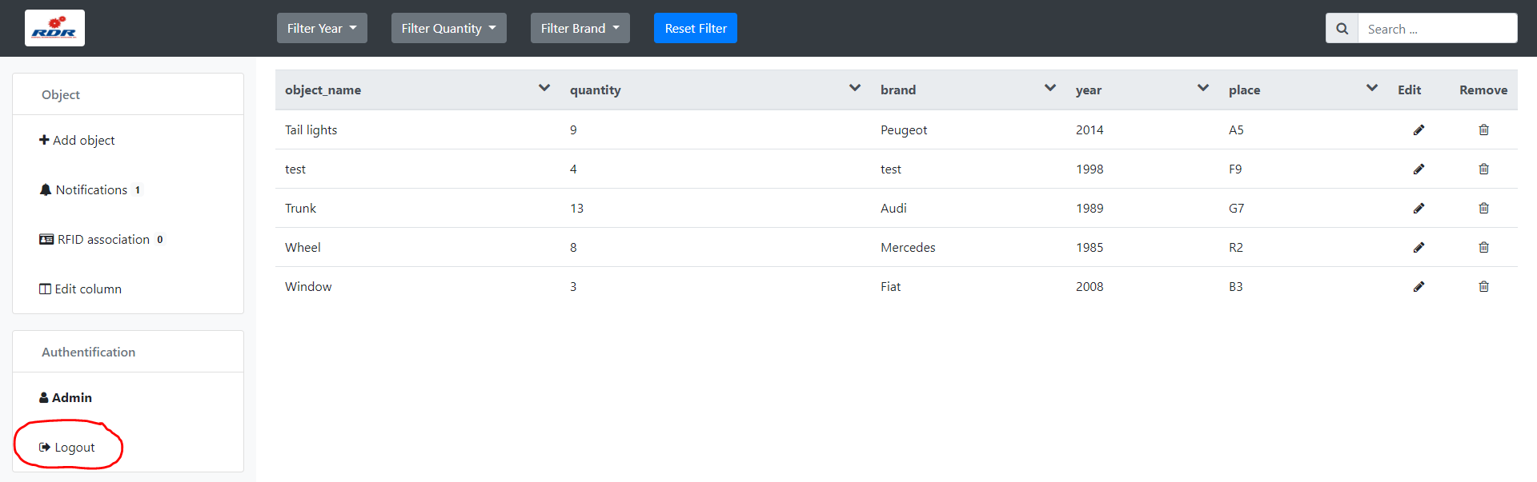

Fig 3: Logout button

## How to edit an object

To edit an object in the website you need to click on pen icon in Edit column of object table

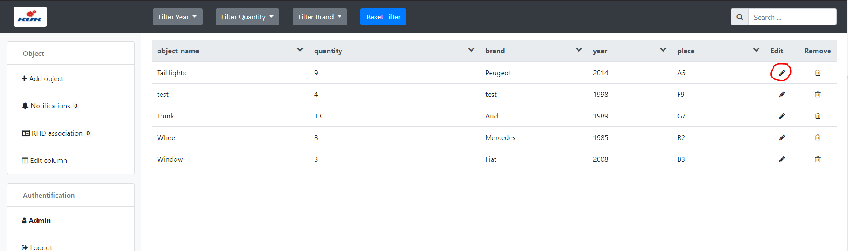

Fig 4: Edit icon

Now, you can modify all the information about specific object, when you finished click on validate button on same column.

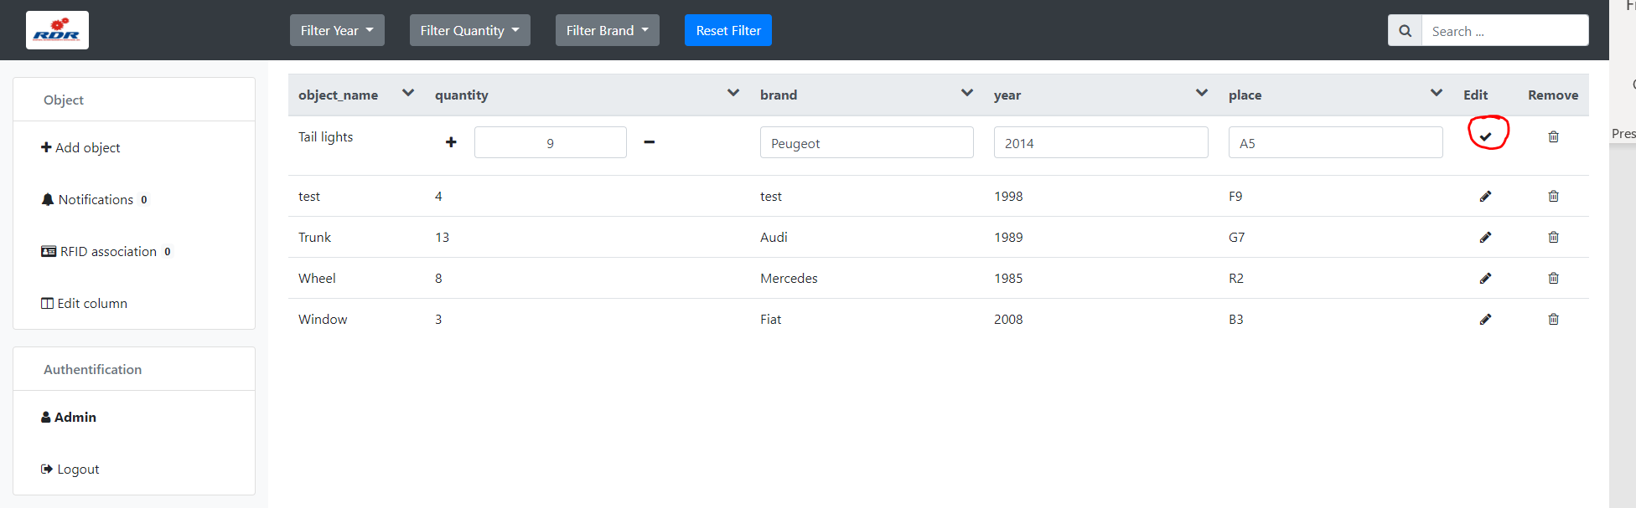

Fig 5: Valid edit button

If you are in default rights, a request will be sent to admin.

## How to remove an object

For remove an object to webpage and website, click on bean icon in remove column of object table.

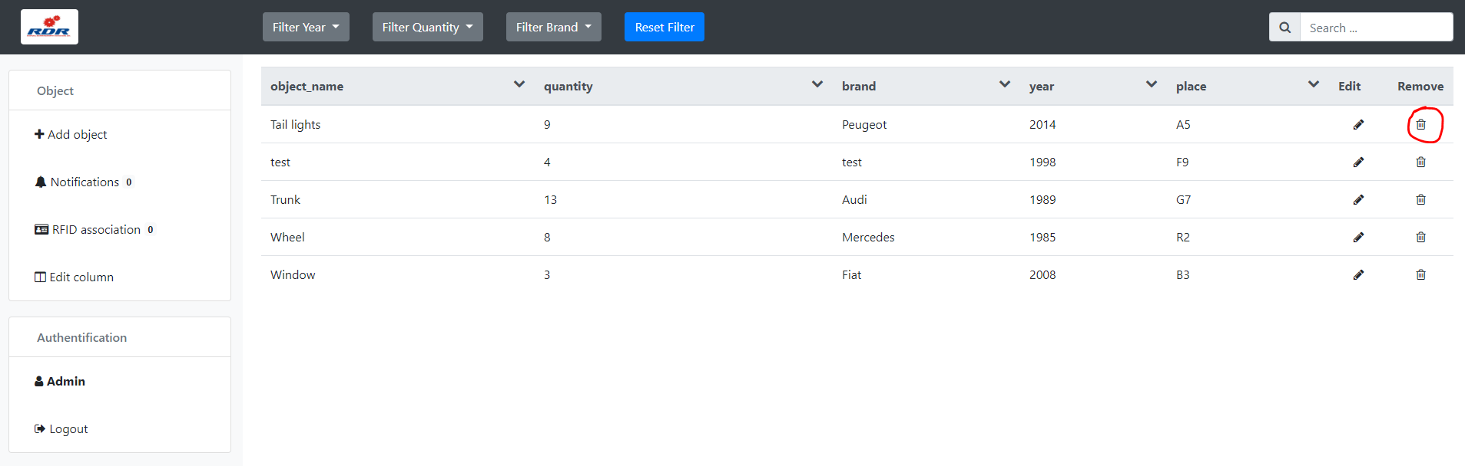

Fig 6: Remove icon

If you are in default rights, a request will be sent to admin.

## How to add an object

To add an object, click on add object button in side menu.

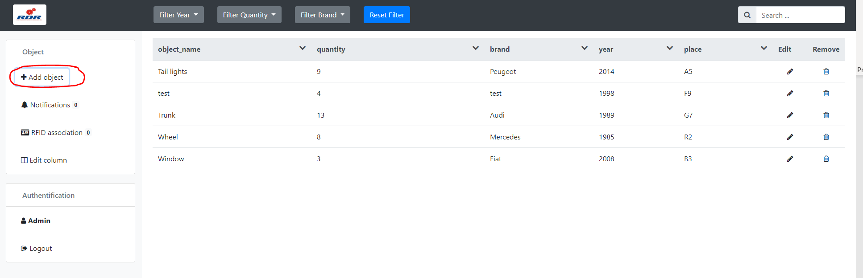

Fig 7: Add object button

You will see a popup and you need to fill the form and click on submit.

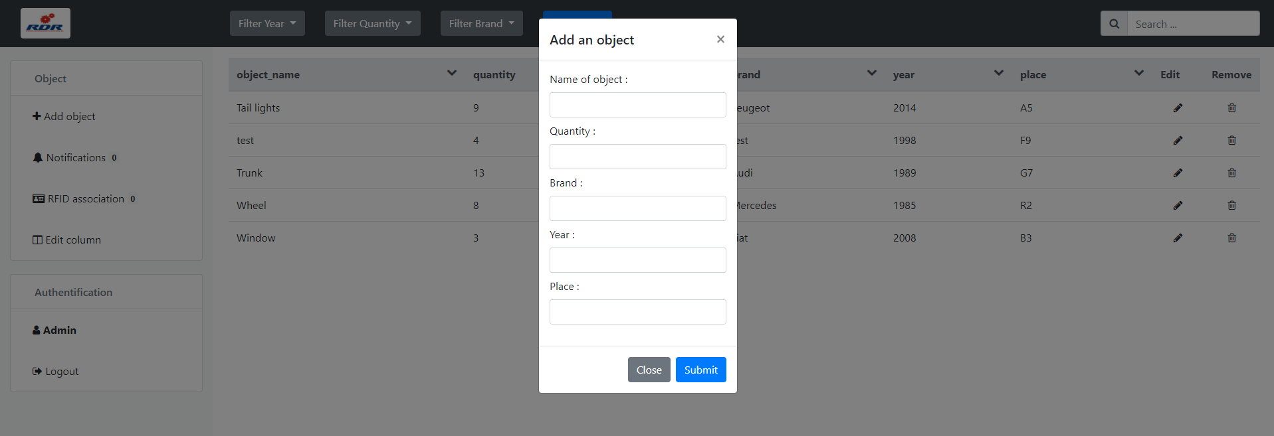

Fig 8: Add an object popup

If you are in default rights, a request will be sent to admin.

## How to confirm client request

If you are in admin rights, you will need to confirm modification. You will see, on notifications button, a badge with a number:

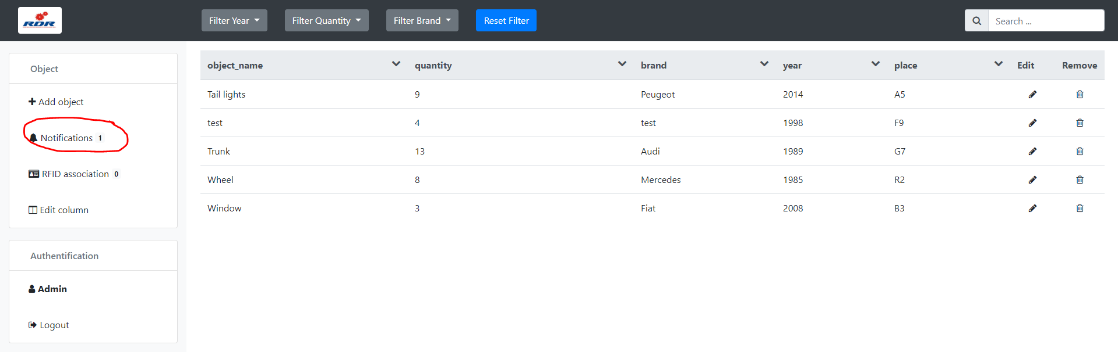

Fig 9: Notifications button

It’s the number of notifications you need to confirm. On this panel, you will see the detail of request:

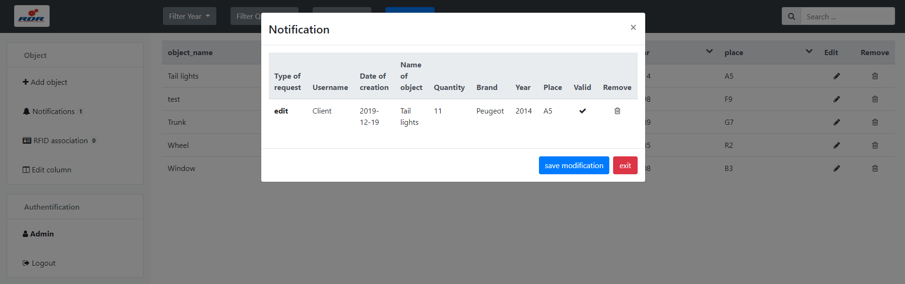

Fig 10: Notification popup

You can valid the request with valid icon of valid column or refuse with been icon on remove column. After that, you can save with save modification button.

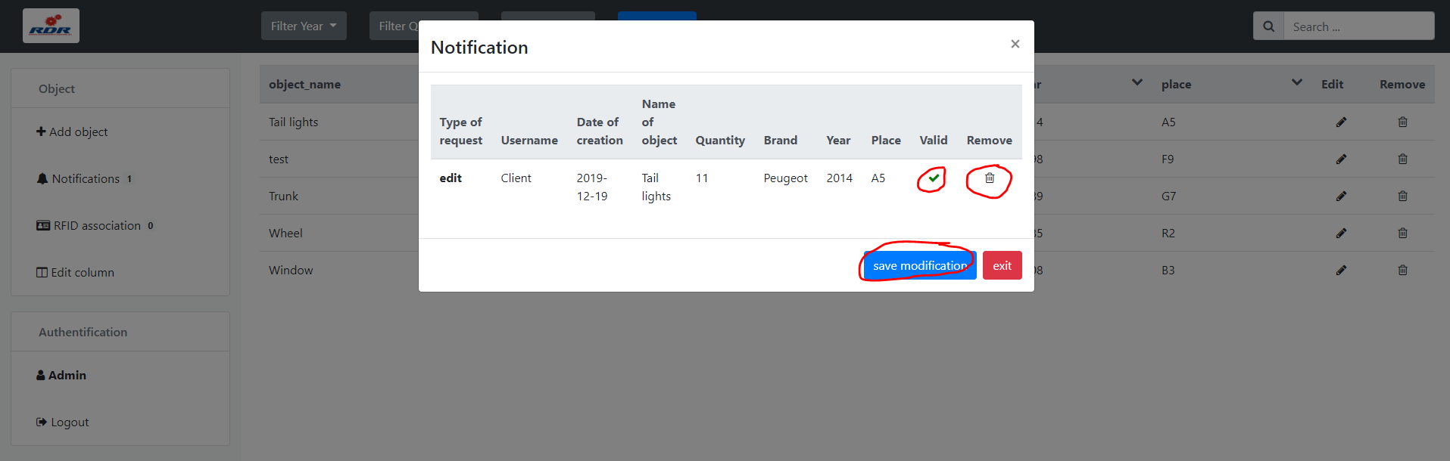

Fig 11: Notification popup features

## How to edit columns

If you are in admin rights and you want to filter columns, click on Edit column on side menu.

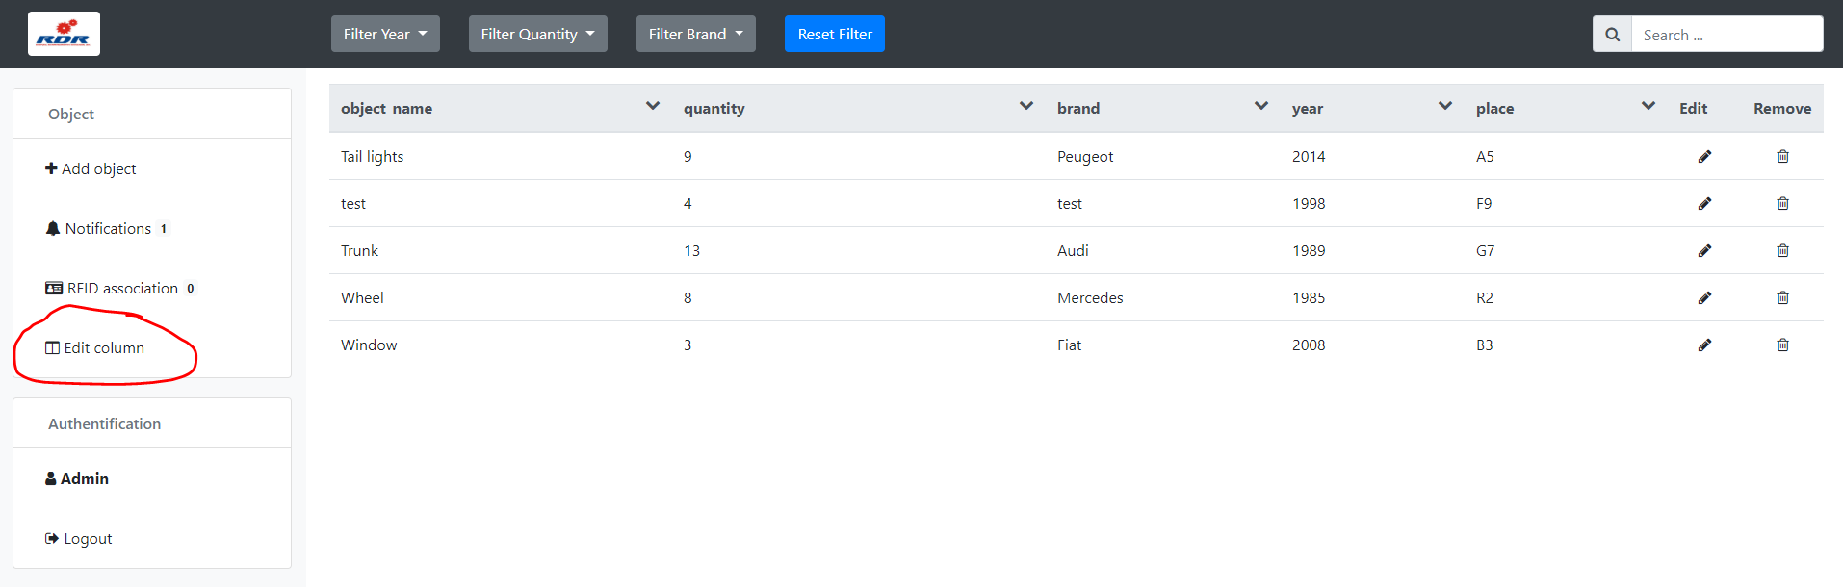

Fig 12: Edit column button

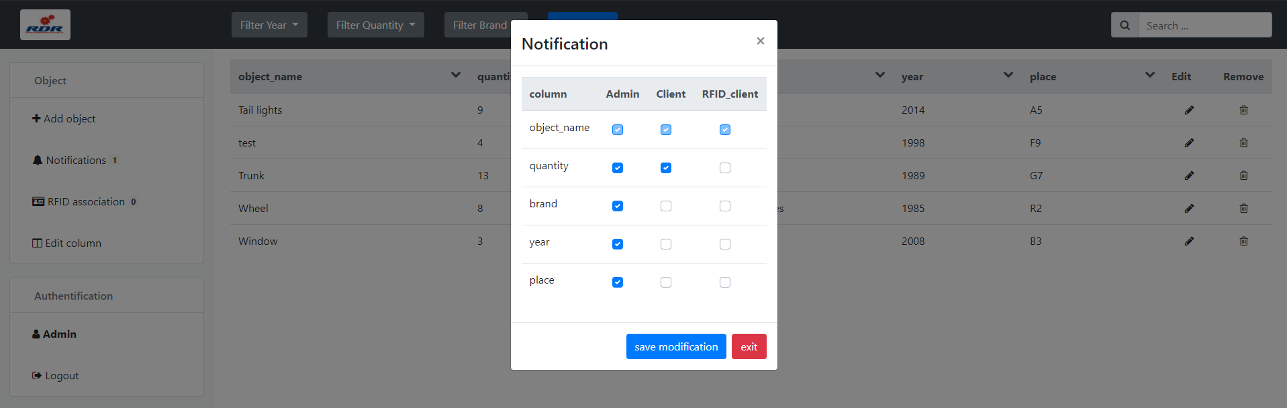

Fig 13: Column popup

You will see all the rights in columns and all object columns in row. You can click on checkbox to toggle columns. When you finished, click on save modification.

## How to associate RFID card to car parts

If you are in admin rights, you will need to associate RFID card to car parts. You will see, on RFID association button, a badge with a number.

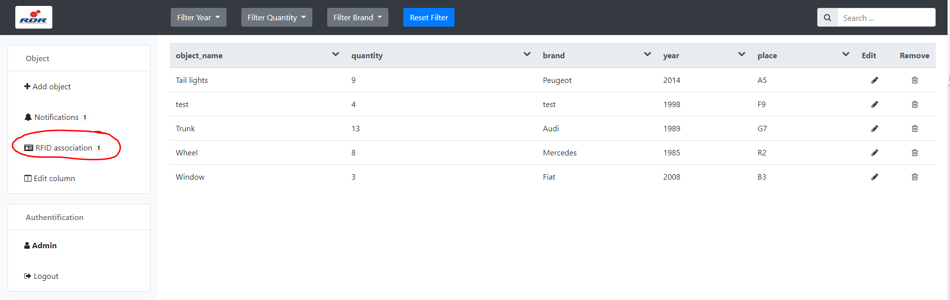

Fig 14: RFID association button

When you click, you will see RFID association page. You have two parts:

* Associate object: When you have new card in RFID, and you need to associate to object
* Edit association: When you want to change RDID association with another object

If you want to go change parts you need to click on this button:

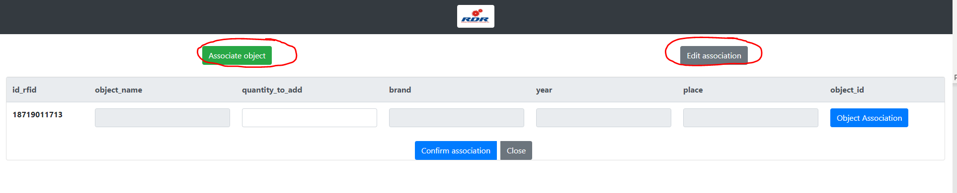

Fig 15: RFID page

In associate object part, if you want to associate object, you need to click on object association button in last column:

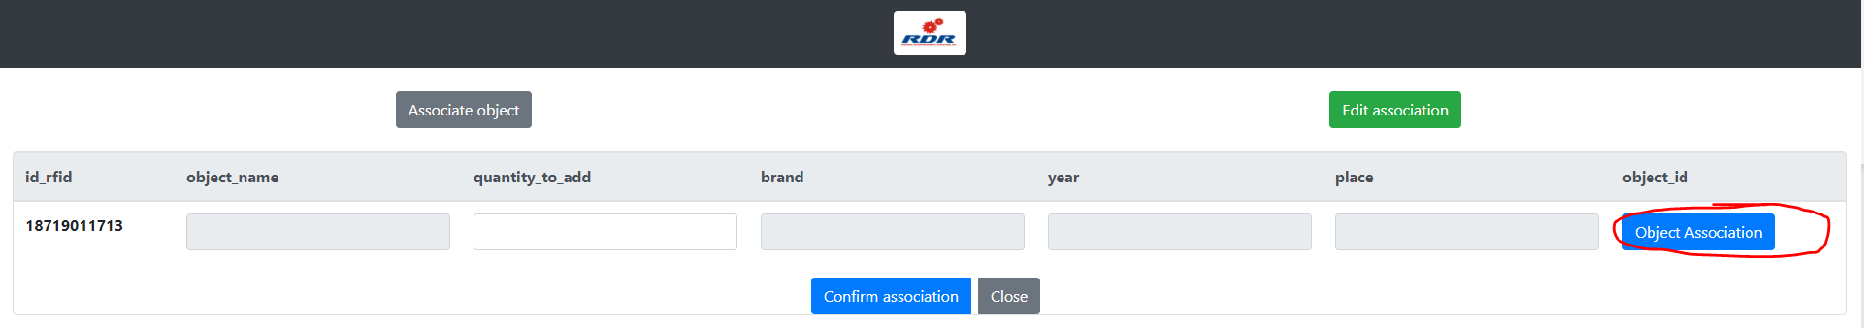

Fig 16: Object association button in associate object panel

Click on specified object you want and click on choose this object button. If you want, you have a shortcut to create new object on add an object button.

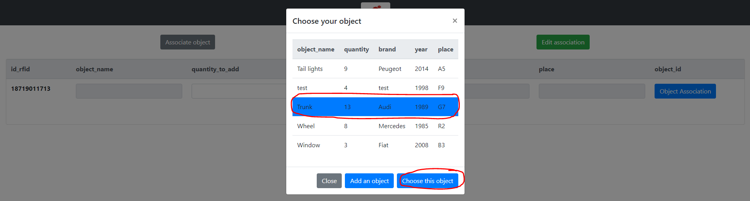

Fig 17: Choose your object panel

After that, you need to specify the quantity you want to increment when you pass your card on the reader. When you finished, click on Confirm association button.

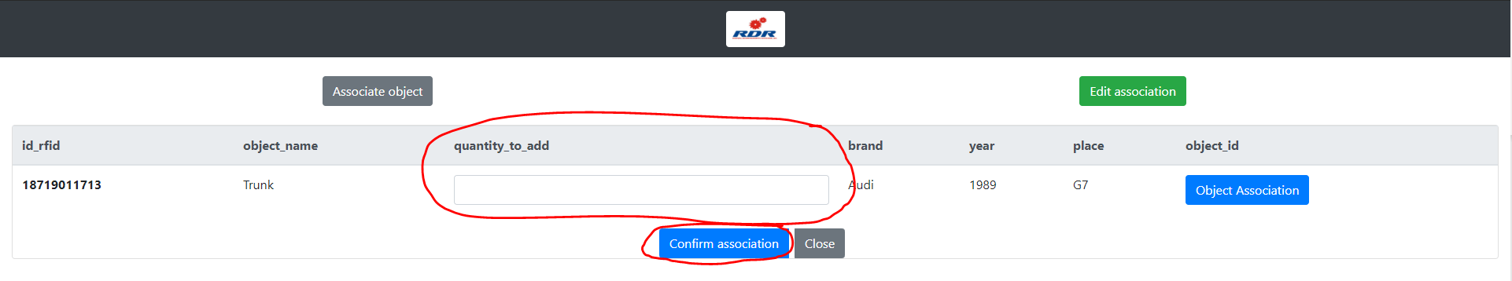

Fig 18: Add quantity input and confirm association button

In edit association part, you can see all RFID cards already associate to an object.

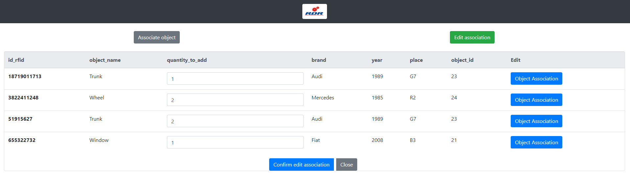

Fig 19: Edit association panel

You can modify the association as the same system than Associate object part.

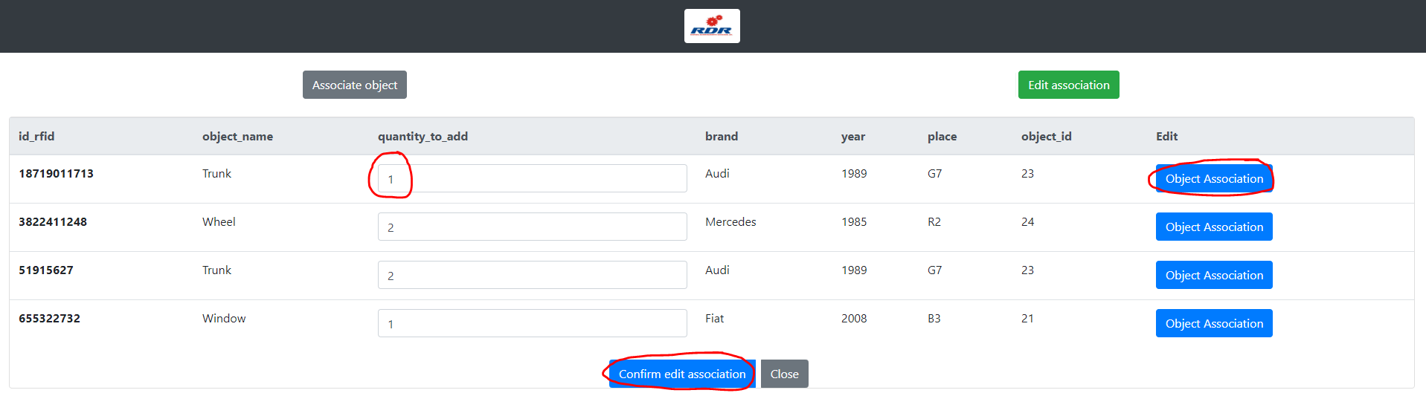

fig 20: Edit association features